# Brainstorm

**TIP**

You can select a sticky note and hit the pencil [switch to sketch] icon to start drawing!

**TIP**

Add customizable tags to sticky notes to make it easier to find, browse, organize, and categorize important ideas as themes within your mural.

**TIP**

Participants can use their cursors to point at where sticky notes should go on the grid. The facilitator can confirm the spot by using the laser pointer holding the **H key** on the keyboard.

#### Before you collaborate

##### A little bit of preparation goes a long way with this session. Here’s what you need to do to get going.

###### 10 minutes

**1**

#### Define your problem statement

##### What problem are you trying to solve? Frame your problem as a How Might We statement. This will be the focus of your brainstorm.

###### 5 minutes

**2**

#### Brainstorm

##### Write down any ideas that come to mind that address your problem statement.

###### 10 minutes

**3**

#### Group ideas

##### Take turns sharing your ideas while clustering similar or related notes as you go. In the last 10 minutes, give each cluster a sentence-like label. If a cluster is bigger than six sticky notes, try and see if you and break it up into smaller sub-groups.

###### 20 minutes

**4**

#### Prioritize

##### Your team should all be on the same page about what's important moving forward. Place your ideas on this grid to determine which ideas are important and which are feasible.

**20 minutes**

#### After you collaborate

You can export the mural as an image or pdf to share with members of your company who might find it helpful.

**Quick add-ons**

# & idea prioritization

**PROBLEM**

**How might we detect of Diabetic Retinopathy ?**

1. Team gathering

**Thenmozhi**

Sharmila

Deep learning way to detect Retinopathy

**Mohammed althaf**

Treatment recommendations

Applications

Mental health

Image processing of images of human retina

Controlling sugar level

Analysis Of retina Fundus Image Analysis

maintaining proper and healthy diet

Use this template in your own brainstorming sessions so your team can unleash their imagination and

taking medicines as directed

use of IOT devices to detect

taking an annual eye test

doing eye exercises

smart photonic contact lenses to detect the diabetes level in eyes.

use of IOT devices to detect

Define who should participate in the session and send an invite. Share relevant information or pre-work ahead.

1. **Set the goal**

Think about the problem you'll be focusing on solving in the brainstorming session.

could be diagonsed by

comprehensive dilated eye

Positive Outlook

early detection of retinopathy by deep learning

taking medicines as directed

taking an annual eye test

following diabetes control measures

Maintaining Physical Health

Smart Application to track BP,Pressure and sugar

Taking prescribed Medicines

Early detection

**Thenmozhi**

Food- concious

Analysis Based Idea Medical Based Ideas Doctor Checkups Physical Activity

## 

early detection of retinopathy by deep learning techniques

following diabetes control measures

could be diagonsed by comprehensive dilated eye exam

doing eye exercises

and gadgets

smart photonic contact lenses to detect the diabetes level in eyes.

Diet

maintaining proper and healthy diet

Controlling sugar level

keeping blood pressure and diabetes under

Pattern Recognition

Computer Vision

Classification Algorithms

Eating less sweets

use of deep learning algorithms for early

Deep

Listening to

1. Share the mural

**Share a view link** to the mural with stakeholders to keep them in the loop about the outcomes of the session.

1. Export the mural

Export a copy of the mural as a PNG or PDF to attach to

start shaping concepts even if you're

Heading for Listening to

control

detection

learning way

to detect

calming music

Analysis Of

retina Fundus

emails, include in slides, or save in your drive.

### not sitting in the same room.

1. Learn how to use the facilitation tools

Use the Facilitation Superpowers to run a happy and

a walk

calming

music

Treatment recommendations

deep learning

techiniques for timely detection

taking

medicines as directed

Retinopathy

Mental

Image

Analysis

**10 minutes** to prepare

productive session.

following diabetes control measures

could be diagonsed by

Image processing of images of

Taking prescribed Medicines

health

Eating less sweets

**Keep moving forward**

**1 hour** to collaborate

**2-8 people** recommended

[**Open article**](https://support.mural.co/en/articles/2113740-facilitation-superpowers)

#### Key rules of brainstorming

To run an smooth and productive session

**sasipriya**

Eating less sweets

keeping blood pressure and diabetes under control

Smart Application to track BP,Pressure and sugar

## 

Avoid high screen time

Regular eye check up

use of deep learning algorithms for early detection

avoid high carbs foods

**kiruthika**

## 

deep learning techiniques for timely detection

using image processing techniques

vitrectomy

application to check the health of vision

taking good care of physical and mental health

eating sugar-free foods

**Sharmila**

## 

Listening to calming music

Analysis Of retina Fundus Image Analysis

Deep learning way to detect Retinopathy

Controlling sugar level

Taking prescribed Medicines

Heading for a walk

pay attention to vision changes

using image processing techniques

comprehensive

dilated eye exam

human retina

Early detection

Avoid high screen time

redular check of diabtes and blood

taking an annual eye test

Pattern

Regular eye

check up

doing eye exercises

maintaining

avoid high carbs foods

Food- concious

Computer Vision

eating

Strategy blueprint

Define the components of a new idea or strategy.

[Open the template](https://app.mural.co/template/e95f612a-f72a-4772-bc48-545aaa04e0c9/984865a6-0a96-4472-a48d-47639307b3ca)

**Customer experience journey map**

Stay in topic.

use of wearable lenses to detect the health of eye

Encourage wild ideas.

redular check of diabtes and blood pressure

pay attention to vision changes

Maintaining Physical Health

early detection of retinopathy by deep learning techniques

**Importance**

Food- concious

vitrectomy

pressure

Recognition

proper and

healthy diet

Positive

Outlook

sugar-free foods

Understand customer needs, motivations, and

obstacles for an experience.

[**Open the template**](https://app.mural.co/template/b7114010-3a67-4d63-a51d-6f2cedc9633f/c1b465ab-57af-4624-8faf-ebb312edc0eb)

Defer judgment.

Listen to others.

Riruthika

Mental health

If each of these tasks could get

Early detection

taking good care of physical and

Image processing of images of human retina

avoid intake of complex carbohydrates foods.

avoid intake of complex carbohydrates foods.

Classification Algorithms

Treatment recommendations

Strengths, weaknesses, opportunities & threats

Maintaining Physical Health

Go for volume. If possible, be visual.

done without any difficulty or cost, which would have the most positive impact?

## 

Positive Outlook

Pattern Recognition

use of IOT devices to detect

Smart Application to track BP,Pressure and sugar

Classification Algorithms

smart photonic contact lenses to detect the diabetes level in eyes.

use of wearable lenses to detect the health of eye

application to check the health of vision

mental health

Identify strengths, weaknesses, opportunities, and threats (SWOT) to develop a plan.

Heading for a walk

[**Open the template**](https://app.mural.co/template/6a062671-89ee-4b76-9409-2603d8b098be/ca270343-1d54-4952-9d8c-fbc303ffd0f2)

**[Share template feedback](https://muralco.typeform.com/to/CiqaHVat?typeform-source=app.mural.co)**

Computer Vision

**Sasipriya**

## 

Avoid high screen time

use of deep learning algorithms for early detection

keeping blood pressure and diabetes under control

Regular eye check up

use of wearable lenses to detect the health of eye

avoid high carbs foods

Mohammed althaf

using image processing techniques

vitrectomy

taking good care of physical and mental health

eating sugar-free foods

pay attention to vision changes

deep learning techiniques for timely detection

redular check of diabtes and blood pressure

application to check the health of vision

[Share template feedback](https://muralco.typeform.com/to/CiqaHVat?typeform-source=app.mural.co)

avoid intake of complex carbohydrates foods.

**Feasibility**

Regardless of their importance, which tasks are more feasible than others? (Cost, time, effort, complexity, etc.)

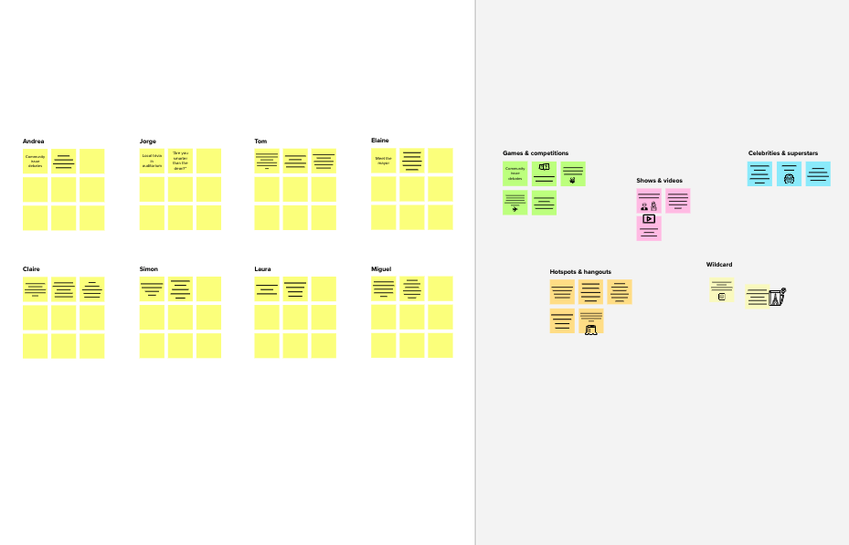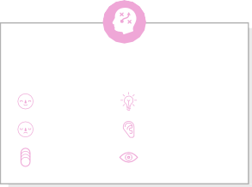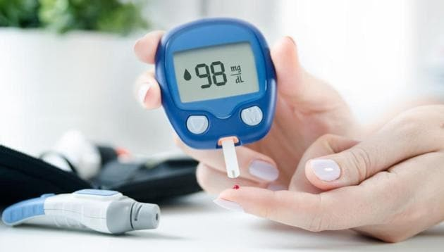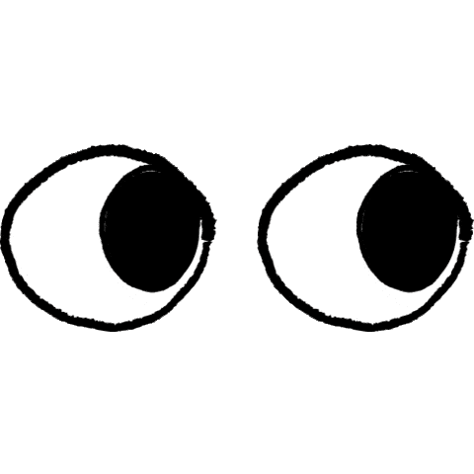

**Template**

**Need some inspiration?**

See a finished version of this template to kickstart your work.

[**Open example**](https://app.mural.co/template/e5a93b7b-49f2-48c9-afd7-a635d860eba6/93f1b98d-b2d2-4695-8e85-7e9c0d2fd9b9)